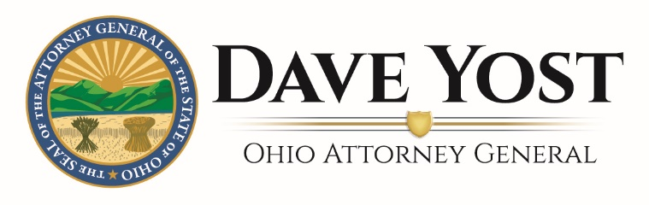

March 13, 2020
Dear Local Official:
The Ohio Attorney General’s Office has received numerous questions regarding the applicability of Ohio’s Open Meetings Act (OMA) during this time of a COVID-19 declared emergency. Under this very limited fact pattern, there may be a basis for local public bodies to use electronic means to meet and comply with the law. You should discuss this matter with your legal counsel before making any decisions.
Ohio’s OMA requires public bodies to take official action and conduct all deliberations upon official business in public meetings that are open to the public at all times. R.C. 121.22. When recently asked, I pointed out that the OMA does not contain an exception to the “in person” requirement during the time of a declared emergency. R.C. 121.22(C).
The OMA provides very few exceptions to this requirement. [See e.g., R.C. 3333.02 (applying to the Ohio Board of Regents) and R.C. 3316.05(K) (applying to members of a school district financial planning and supervision commission, if provisions are made for public attendance at any location involved in the teleconference.]
Yesterday, Dr. Amy Acton, Director of the Ohio Department of Health (ODH), issued an Order targeted at preventing the spread of COVID-19, a highly communicable disease. Dr. Acton issued this Order pursuant to the authority granted to her by Ohio Revised Code Section 3703.13. In relevant portion, that statute gives ODH supervisory authority over “all matters relating to the preservation of the life and health of the people”. R.C. 3703.13. It further provides that ODH shall “have ultimate authority in matters of quarantine and isolation”. Id. Dr. Acton and Governor Mike DeWine held a press conference at which they detailed the COVID-19 epidemic in Ohio, the continued spread of this as-yet incurable virus, and how we as Ohioans can best stop it in its tracks. The Order issued by Dr. Acton addresses all of these critical points.
Dr. Acton’s Order primarily addresses “mass gatherings”, which it defines as “any event that brings together one hundred or more persons in a single room or single space at the same time”. It is possible that a meeting that must be public under the OMA qualifies as a “mass gathering” subject to the Order. Thus, on its face, the Order could prevent a public body from holding a meeting necessary for the continuation of governmental operations. But even if it does not, the Order is not so limited such that it only provides guidance as to mass gatherings. Specifically, it also states:
“Regardless of whether an event or gathering falls within the definition of mass
gathering, all persons are urged to maintain social distancing (approximately
six feet away from other people) whenever possible and to continue to wash hands,
utilize hand sanitizer and practice proper respiratory etiquette (coughing into
Elbow, etc.).”

To summarize, ODH with ultimate authority over issues of isolation and quarantine is currently forbidding mass gatherings and advising social distancing at all others. At the press conference both Dr. Acton and Governor DeWine took their advice one step further. In the interest of stopping the spread of this highly communicable disease, both urged Ohioans to stay home and avoid unnecessary contact with one another. Thus, we are now presented with a situation in which a public body might not be able to comply with both the terms of the Order and the Open Meetings Act. Stopping the business of government is not an option, and we must now reconcile the two.
To do so, it is necessary to consider the applicability of the OMA’s “in person” requirement in the context of Dr. Acton’s Order and the rapidly developing information about the spread of COVID-19. As we must always do when faced with the application of two different—and in this situation, somewhat competing—statutes, we must give effect to both. That is, we must give effect to the OMA’s “in person” requirement, while also recognizing and complying with Dr. Acton’s “ultimate authority” over matters of isolation to stop the spread of a highly infectious disease. That task is possible here.
In this limited circumstance, where the Governor has declared a state of emergency and the Director of the Ohio Department of Health is limiting gatherings so as to prevent the spread of COVID-19, but the business of government must continue, it is reasonable to read the OMA’s “in person” requirement as permitting a member of a public body to appear at a public meeting via teleconference. This interpretation gives effect to both R.C. 121.22 and R.C. 3701.13. It is also consistent with the United States Centers for Disease Control’s recent guidance, issued in response to the national COVID-19 epidemic, to use videoconferencing for meetings when possible. See, https://www.cdc.gov/coronavirus/2019-ncov/downloads/workplace-school-and-home-guidance.pdf.
Of course, if a member of a public body chooses to appear via teleconference or telephone, it is imperative that all other requirements of the OMA be fulfilled. A quorum must still be present, whether in person, on the phone, or in some combination thereof. In the event that a member appearing telephonically is cut off, the public body should cease all discussions and deliberations until the member can be reconnected.
Further, even in this time of a public health crisis, public access to the business of Ohio’s public bodies is still vital. It is also still required by the OMA. Although the OMA does not specifically dictate how a meeting is made “open” to the public, in the interest of complying with both Dr. Acton’s Order and the OMA a meeting could be made “open” to the public by live-streaming it through the internet or on television. If a public body gives the public access to a meeting electronically and the members of the body appear telephonically, the body must still ensure that the public is able to hear the discussions and deliberations of all of the members, even those who are present via telephonic means. Finally, all other requirements of the OMA will apply, including those that govern notice, executive session, and the taking of meeting minutes.
The practices outlined above would likely satisfy the requirements of the OMA. They are also consistent with the spirit of R.C. 5502.24(B), which provides that if, due to a declared emergency, it becomes “imprudent, inexpedient, or impossible to conduct the affairs of a local government at the regular or usual place,” the governing body may meet at a previously designated alternate location and dispense with legal requirements that qualify as “time-consuming procedures and formalities”. During a declared emergency, certain OMA requirements could fall within that category.
As a final word of unsolicited, non-legal advice: please note that the procedure outlined in this letter is meant to address the unique situation with that all of Ohio is dealing with. Now is not the time to rely on this guidance in order to enact legislation unrelated to the instant emergency that is better reserved for the normal operations of government (e.g. to pass a new tax or enact a new regulatory scheme). It is also important that county prosecutors, local law directors, and city attorneys independently research whether there is any case law in their respective jurisdiction that would specifically prohibit the procedure that I have outlined here. This office does not represent local governments, and this letter is offered as guidance regarding our reading of the law.
This Office’s Sunshine Law Manual addresses the modified duties of a public body during a declared emergency. See, Ohio Attorney General’s 2020 Sunshine Law Manual, at pgs. 107-109. Further, my Office’s Public Records Unit remains available for consultation.
Sincerely,
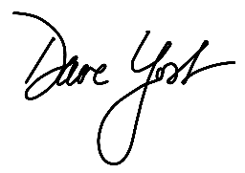
Dave Yost
Ohio Attorney General

