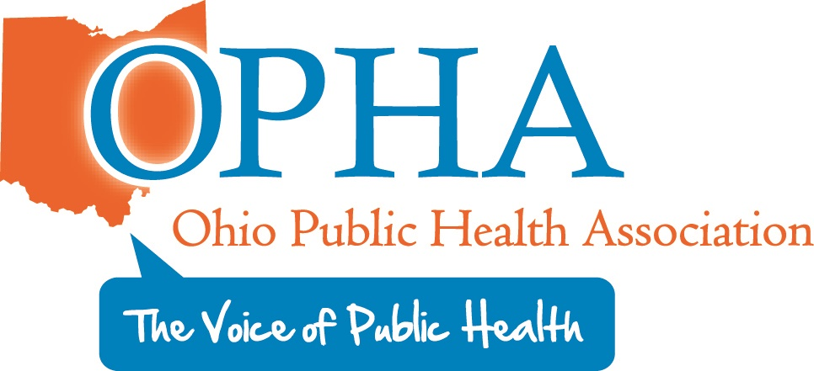

Welcome
Tunu Kinebrew, Vital Statistics Section Chair OPHA

Introduction of OPHA
David Maywhoor, OPHA Executive Director

Sherly Suppa
Sheryl has been with the Jefferson County Health Department for 21 years. She started out as a Vital Statistics Clerk and worked her way up to the Registrar position in 2012. She is the Assistant Fiscal Officer for the Health Department. She has an Associate’s Degree in Medical Assisting. She is currently working on accreditation for the health department. She likes spending time with her 3 children and 3 grandsons.

Hosted at the
Quest Conference Center
8405 Pulsar Place
Columbus, Ohio 43240

Lodging
Hampton Inn and Suites
8411 Pulsar Place
Columbus, Ohio 43240
614-885-8400
OPHA Vital Statistics
VITAL STATISTICS
CONFERENCE 2019
VITAL STATISTICS IN OHIO TODAY
August 14, 2019

Lunch/Shirley Hayslet Award
11:50 am

Central Issuance: Compliant vs Standard
Tom Wilson, Ohio BMV Administrator Field Operations

Break

Customer Service
Ryan Cairney, HCM Senior Analyst
Ohio Department of Health Workforce Development

To Scan or Not to Scan: That is the Question!
Mark Conrade, IT Director Fairfield County
Ohio Electronic Records Committee

Closing
Tunu Kinebrew OPHA Chair Vital Statistics- Cincinnati Vital Statistics
Donna Merriman, OPHA Co-Chair Vital Statistics – Wayne County Vital Statistics

Injury in Ohio: Data and Prevention Efforts
Luke Werhan Ohio Violent Death Reporting

Break

Health and Equity in All Policies: A Community Opportunity
David Maywhoor, OPHA Executive Director

Ronda Hess
Ronda is a 17 ½ year employee with the Delaware General Health District. Ronda works in the Vital Statistics division where she has served as Deputy Registrar for over 16 years. Throughout her career she has served on multiple committees at the Health District. Currently, she serves as the Co-Chair on the Delaware County Child Fatality Review Committee. Ronda is very dedicated to her work at the Health District and the customers she serves. The Delaware General Health District and Rhonda are highly regarded by Funeral Homes across the State because of their exceptional customer service and knowledge of Vital Statistics.

Ohio History Connection Preserving your Records
Amanda Rindler, Local Records Government Archivist

2020 Census – US Census Bureau

