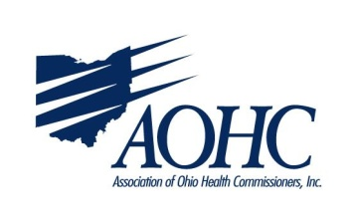
Health Commissioner University 2019
AOHC Office, 110A Northwoods Blvd, Columbus, Ohio

Tuesday, April 30, 2019
9:30 am Welcome and introductions – by HCU Planning Committee –
I wish I knew then, what I know now…” – for lunch discussion
9:45 am-12:30 pm Overview of Public Health Law and Local Health Districts
Break
Relevant Ohio Attorney General Opinions
12:30-1:00 pm Lunch at AOHC
1:00 to 2:00 pm Ohio’s Sunshine Laws
2:00 – 3:00 pm Fiscal/Audit Responsibility

Tuesday, May 28, 2019
9:30 to 10:30 am Obligations of the Board of Health
10:30 to 10:45 am break
10:45 to 11:30 am Legislative Update
11:30 to 11:45 am Introduction to LPHSC
11:45 to 12:15 pm Ohio Public Health Associations and Partnerships
12:15 to 12:45 pm lunch
12:45 to 1 pm Contracts for health commissioners and negotiating points
1:00 to 1:15 pm PHAB Resources
1:15 to 1:45 pm Introduction to AOHC
1:45 to 2:15 pm Working with Townships and other partners
2:15 to 3 pm Case study for practicing authority of health commissioner and table top exercises
3:00 to 3:15 pm Homework for June – send in ethics questions
Questions and Wrap up

Tuesday, June 25, 2019
9:30 to 11 am Information for Decision Making and Sources of Funding
11 to 11:15 am Break
11:15 to 1:15 pm Personnel Issues for Public Health / Personnel Training Tips and Techniques
1:15 to 1:30 pm Lunch
1:30 – 2:15 pm Health Commissioner Ethics Obligations and Real Life Examples of Ethics Concerns in Public Health
2:15 – 3:15 pm Open Discussion, Q&A, Wrap up

