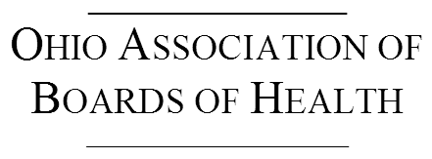

Annual Meeting Agenda
September 15, 2018

10:00 AM Welcome and Opening
10:05 AM Board of Health Governance - Joseph Mazzola, MPA, Health Commissioner, Franklin County Board of Health
11:30 AM Lunch and Meeting
1:00 PM Board of Health Orientation - Sharon Stanley, PhD, Ross County Board of Health
2:30 PM Meeting Closes

