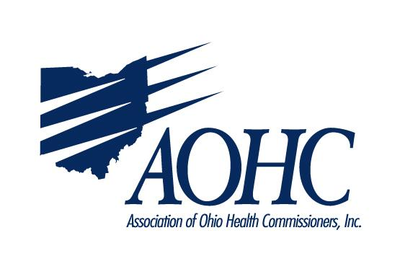
Leadership Essentials for Health District Success (LEHDS)
April 23-24, 2019
Cost $285 per person, includes 1 hotel night and 2 lunches, 1 breakfast
Classes held at AOHC Office, 110A Northwoods Blvd, Columbus, Ohio
Hotel: TBD
Tuesday, April 23
8:30 to 8:45 am Welcome and introductions
8:45 to 10:00 am Performance Management
10:00 to 10:15 am Break
10:15 to 11:30 am Progressive Discipline and Performance Evaluations
11:30 to 12:15 pm Quality Improvement
12:15 to 1 pm Lunch (included)
1:00 to 1:45 pm Theft in Office
1:45 to 2:45 pm Worker’s Compensation
2:45 to 3:00 pm break
3:00 to 4:15 pm Attitude, Change, and Team Building Activity
4:15 to 5:00 pm Building Relationships with Ohio Legislators

Wednesday, April 24
7:45 to 8:15 am Breakfast at AOHC
8:15 to 9:00 am Cost Methodology
9:00 to 10:00 am Recruitment, Retention, and Policy Management
10:00 to 10:15 am Break
10:15 to 10:45 am Layoffs
10:45 to 11:15 Terminations
11:15 to 12:15 FMLA/FLSA
12:15 to 12:45 pm Lunch (included)
12:45 to 1:45 pm LHD HR Law Case Example
1:45 to 2:00 pm Essential HR
2:00 to 3:00 pm Community Engagement
3:00 to 3:15 pm Break
3:15 to 4:00 pm Funding Sources and Levies

